User Manual

1. **Administrator Login**

Figure_ below shows the administrator’s log in page, the user should log in to proceed to the home page. User should have username and password.

To log, in please follow the steps:

1. Enter the username and password.

2. Click the “Login” button. The system will validate the username and password.

3. If login is valid, you will be redirected to the home page.

4. If login failed, an error message will be displayed, and you have to reenter the username or

password.

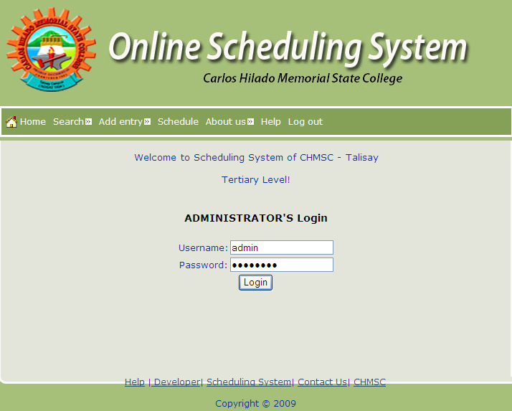

**Figure_ : administrator Log in Page**

**2.0 Search Teacher, Student and Room schedule**

Figure_ below shows the search menu where the administrator can search schedules of teachers, students and rooms.

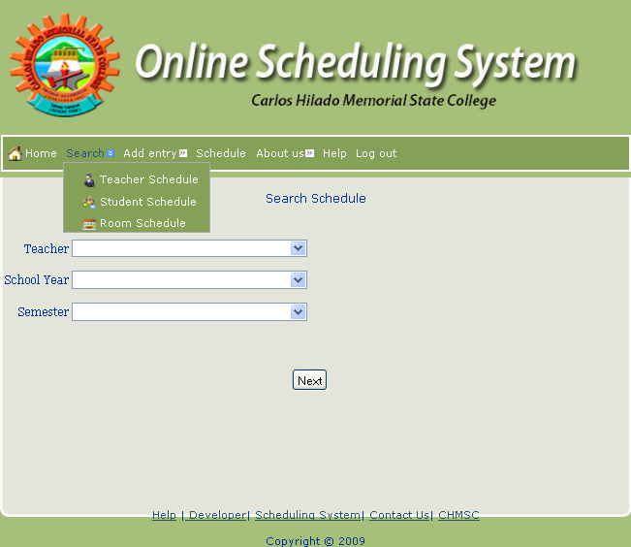

**3.0 Room, Department, School Year**

Figure_ below shows the Add Entry menu where the administrator can add and view the user, teacher, course, subject, room, department and school year.

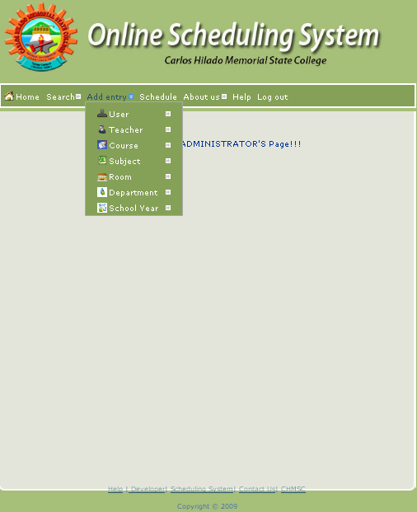

Figure_ below shows the User Link where the administrator can add or view new users.

To add/view users, Just Click on the Add Entry, User, add/view .

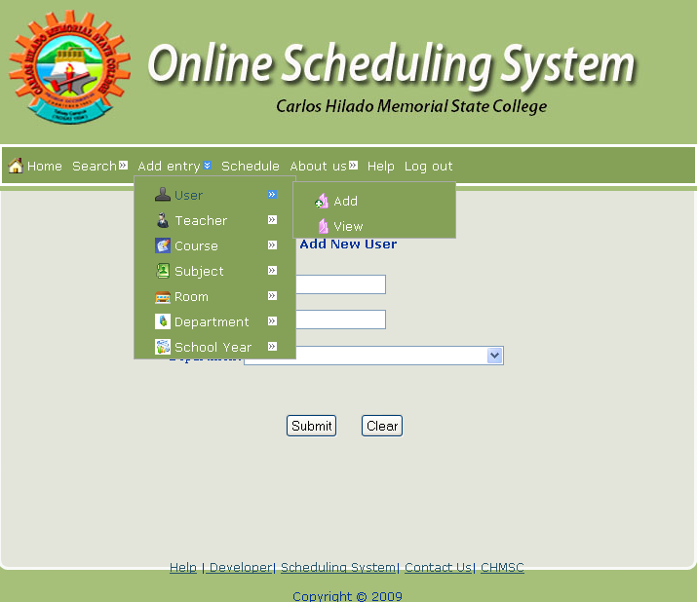

Figure_ below shows Teachers Link where the administrator can add or view Faculty name and its department.

To add/ view teachers, just click on the Add Entry, Teacher, add/view.

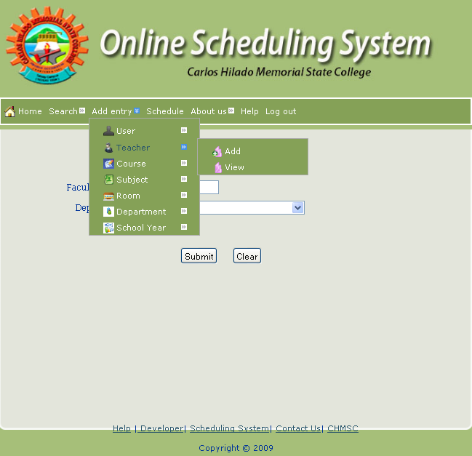

Figure_ below shows the Course Link where the administrator can add or view the courses.

To add/ view courses, just click on the Add Entry, Course, add/view.

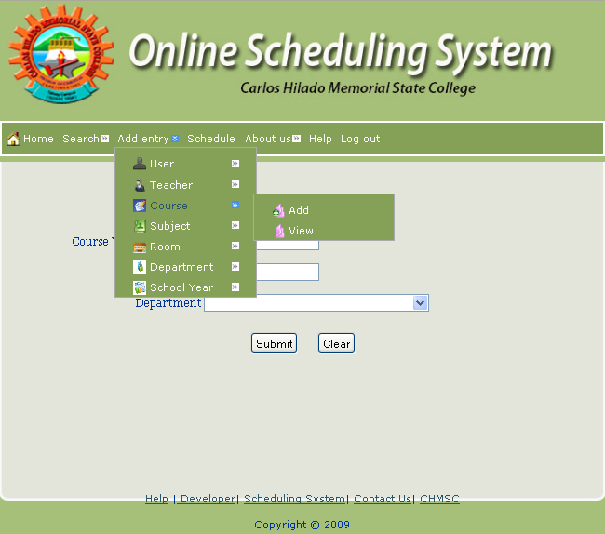

Figure_ below shows the Subject Link where the administrator can add or view the subjects’ information.

To add/ view subjects, just click on the Add Entry, Subject, add/view.

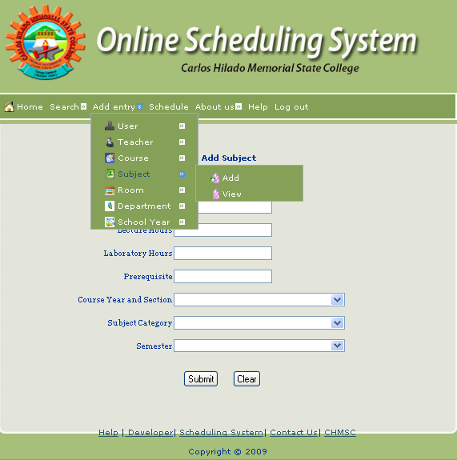

Figure_ below shows the Room Link where the administrator can add or view the room information.

To add/view rooms, just click on the Add Entry, Room, add/view.

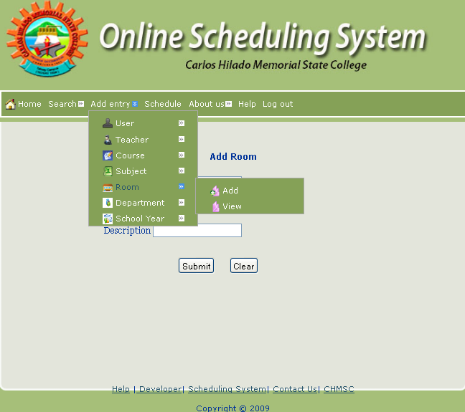

Figure_ below shows the Department Link where the administrator can add or view the department.

To add/view departments, just click on the Add Entry, Department, add/view.

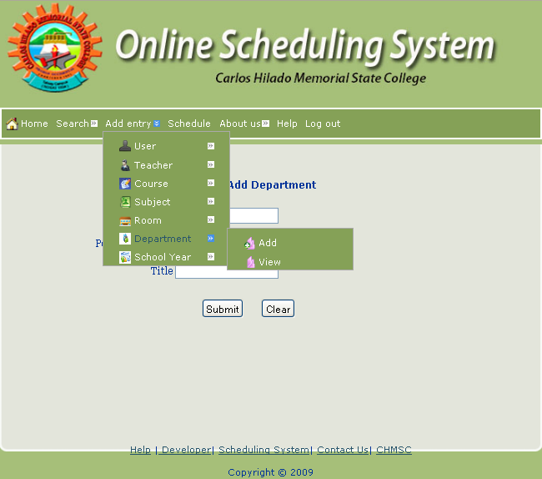

Figure_ below shows the School Year Link where the administrator can add or view school year.

To add/view school year, just click on the Add Entry, Department, add/view.

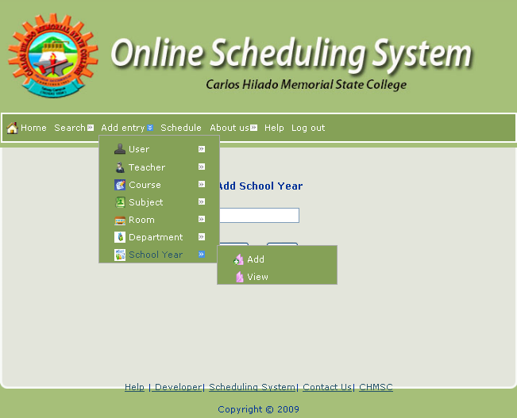

Figure_ shows the Schedule Menu where the administrator can add new schedules.

To add new schedules, simply fill-up the information needed.

